Burden of MDR Acinetobacter in a Tertiary Care Hospital

Ms. Monisha B1, Dr. Rashmi P. Mahale2, Dr. Sowmya G. S3, Dr. Ranjitha Shankaregowda4

*2,3,4Associate Professor, Department of Microbiology, JSS Medical College & Hospital, Mysuru-570004*

*1PhD Research Scholar, Department of Microbiology, JSS Medical College & Hospital, Mysuru-570004*

**Abstract: Acinetobacter is a significant nosocomial pathogen that is multidrug resistant (MDR), associated with hospital infections globally, and has evolved resistance to most antibiotics by creating a variety of acquired -lactamases (1), (3). This study examined the prevalence of MDR Acinetobacter and its effects in tertiary care hospital patients in south India. Clinical samples including BAL, ET exudates, urine, blood, and other bodily fluids were collected and processed over the course of eight months in accordance with the prescribed protocol. According to CLSI recommendations, the VITEK-2 system performed the identification and AST(5-7). MDR Acinetobacter was defined as organisms resistant to any one medication in three categories of antimicrobials(8). During the study period, 19,602 samples were obtained for culture and sensitivity testing, of which 357 (1.82%) were Acinetobacter isolates, of which 98 (27.45%) were MDR isolates. The majority of MDR Acinetobacter infections came from respiratory tract samples, including ICU patients older than 60 years. The majority of these MDR isolates were intermediately resistant to colistin and all first-line antibiotics(7)(8). We can therefore draw the conclusion that there are few alternatives for treating these infections with antibiotics like polymyxin B and colistin sulfate and that the highly resistant Acinetobacter MDR strains cause a high rate of morbidity and mortality. We can use infection control procedures to stop the spread of related organisms within the hospital by detecting the MDR pathogens.**

**Keywords: Acinetobacter baumannii, antimicrobial susceptibilty, colistin, multidrug resistance.**

INTRODUCTION

*Acinetobacter* is a Gram-negative, non-motile, aerobic coco-bacillus that possesses a number of potent virulence factors (1-2). *Acinetobacter* spp. infections include blood-stream infections, skin and soft tissue infections, wound infections, secondary meningitis, and pneumonia related to ventilator use (3). This organism is a frequent pathogen linked to outbreaks in hospital settings because it can live in a variety of environmental conditions and remains on surfaces for a long time (3-6). Hospital strains of *Acinetobacter* spp. typically affect very unwell patients in intensive care units (ICUs), especially those who require mechanical ventilation and patients with wound or burn injuries (7). Over the past few decades, *Acinetobacter* spp. has become a prominent MDR nosocomial pathogen that has been reported more frequently, likely as a result of the increased use of broad-spectrum antibiotics in hospitalized patients. (8), (9). *Acinetobacter* was listed as one of the pathogens that are on "red alert" by the Infectious Diseases Society of America (ISDA). MDR *Acinetobacter* is becoming more common, according to numerous research, however resistance rates might differ greatly depending on the hospital, city, or nation involved (10-13). The crude death rate is high because MDR *Acinetobacter* infections are typically found in seriously unwell patients. *Acinetobacter*, a multidrug-resistant organism, has evolved resistance to the majority of the current antibiotics, including carbapenems, the treatment of choice for serious infections(14). Efflux pumps, porin mutations, and the production of acquired -lactam hydrolyzing enzymes, such as Class A (extended-spectrum -lactamases, or ESBLs), Class B (metallo--lactamases, or MBLs), Class C Ampicillinase (AmpC), and Class D -lactamases, are the main mechanisms for -lactam resistance in *Acinetobacter* spp. Because it is frequently plasmid-mediated, carbapenem resistance resulting from the production of MBL and other carbapenemases has the potential to spread quickly in hospital settings (15-17). Early detection of drug resistance is necessary for proper antibiotic selection to treat infections in hospitalized patients and to start effective infection control measures to prevent their spread within the hospital settings. This investigation was conducted to ascertain the prevalence of MDR *Acinetobacter* infections and their pattern of drug susceptibility in a tertiary care hospital while keeping the aforementioned viewpoints in mind.

METHODOLOGY

For a period of 8 months (January-August 2022) clinical samples like BAL, ET exudates, urine, blood samples and other body fluids were received for culture and sensitivity and processed according to the standard protocol at a tertiary care hospital in south India. In brief, all samples received for culture and sensitivity were inoculated onto Mac-Conkey and blood agar. Identification and antimicrobial susceptibility of the organisms morphologically resembling *Acinetobacter* spp., were done by VITEK-2 system with the reference of the CLSI guidelines. Organisms resistant to any one drug in three groups of antimicrobials were identified as MDR *Acinetobacter*.

A detailed demographic data of patients whose samples yielded *Acinetobacter* was noted which included, age, gender, diagnosis, sample, department, ICU, month, ward and the antibiogram which further enabled in compilation of rate of the multidrug resistance in *Acinetobacter* spp..

RESULTS

A total of 357 (1.82%) isolates of *Acinetobacter* *spp.* were isolated in this study for over a period of 8 months. Of these 357 isolates, 152 (42.58%) were *A. baumannii,* 180 (50.42%) were *A*. *baumannii* *complex,* 8 (2.24%) were *A. haemolyticus,* 3 (0.84%) were *A. junnii,* 14 (3.92%) were *A. Lowfii.*

Maximum number of *Acinetobacter* spp. were isolated 115 (32.21%) from patients who were 60 years and above, followed by 63 (17.64%) isolates with age group 51-60 years and least number of isolates 21 (5.88%) were from patients with age group 11-20 years as represented in Table 01.

Isolation of *Acinetobacter* spp. was higher 238 (66.66%) in males, and only 119 (33.33%) were female patients.

Maximum number of *Acinetobacter spp.* were isolated from endo-tracheal aspirates 138 (38.66%), followed by sputum 67 (18.77%), as shown in Graph 01 and Table 02.

Majority of the isolates 331 (92.71%) were from in-patients and only 26 (7.28%) were isolated from outpatients.

Among the inpatient isolates, maximum number were isolated from Neurosurgery department 69 (19.32%) followed by medical ward 64 (17.92%), as represented in Table 03 and Graph 02. Of the 331 in patient isolates, 251 (75.83%) were from ICUs and 80 (24.16%) were from non-critical areas.

Using the vitek-2 approach, antimicrobial susceptibility testing was carried out, which showed that majority of the isolates were sensitive to tigecycline 61 (61.22%) and minocycline 18 (18.37%) followed by levofloxacin and 17 (17.35%). All the isolates 98 (100%) were found to be intermediate to colistin, as shown in Table 04. Analyzing the antimicrobial susceptibility pattern, 98 isolates of *Acinetobacter baumannii* were identified as MDR.

Of the 98 MDR *Acinetobacter baumannii* isolates, Maximum number 31 (31.63%) of MDR isolates were isolated from patients who were 60 years and above, followed by 19 (19.39%) in the age groups of 41-50 years and least number 4 (4.08%) from 11-20 years of age group. Endo-tracheal aspirate 42 (42.85%) yielded the most number of isolates followed by Pus and blood samples with 14 (14.29%) isolates each. Majority of the samples 93 (94.90%) were from in-patients and only 5 (5.10%) were isolated from outpatients. Majority of the samples were isolated in the month of May 19 (19.39%) followed by August 17 (17.35%) and April 14 (14.29%) and also maximum number of samples were from **neurosurgery ward 30** (30.61%) and general medicine ward 17 (17.35%) followed by Surgery ward 11 (11.22%). The least number of isolates were from the dermatology, urology and rheumatology wards with only 1 (1.02%) isolate from each department. The rate of isolation from ICU and Non-ICU ratio was observed as 3:1 i.e. 73 (74.49%) isolates were from various ICUs and 25 (25.51%) were from Non- ICU.

DISCUSSION

In hospitalized patients, particularly those in intensive care units, *Acinetobacter* is a significant nosocomial pathogen linked with a wide range of ailments. This poses a greater challenge to patient management and infection control. It is quite concerning that MDR *Acinetobacter* species are spreading globally. This study made an effort to look into the prevalence of MDR *Acinetobacter* species in an Indian tertiary care facility. In the present study, 32.21% of the isolates were from the patients who were 60 years and above, however, Santhosh Kumar Yadav et.al (1) has reported a lower rate (14.9%) of their isolation from patients above 60 years of age and Mehta Pooja B et.al (5) have reported 84.3% isolation rate in 31-60 years of age.

In our study, isolation from the Intensive Care Units (ICU) accounted to a total of 75.83% that is similar to the study conducted by Santhosh kumar Yadav et.al. (1) Where Isolation from Intensive Care Unit (ICU) was 74.49% showing that a greater number of samples from ICU were included in both the study.

In our study, 66.66% included male patients and 33.33% included female patients. Whereas Mehta Pooja B et.al (4) and Santhosh Kumar Yadav et.al. (1) have reported an isolation rate of 52.9% and 58.3% respectively from male patients and 47.1% and 41.7% respectively from female patients.

In our study, majority of the isolates were from respiratory samples like deep Endotracheal aspirates (38.66%) from patients on mechanical ventilation, the high isolation rate from respiratory samples like ET aspirates is due to the high referral rates to this tertiary care hospital. Mehta Pooja B et.al. (5) and Santosh Kumar Yadav et.al. (1) have reported similar isolation rates (41.17%) and (47.2%) respectively from respiratory samples, however Melda Sinirtas et.al (6) have reported a higher rate of isolation from deep Endotracheal Aspirates (77%).

In this investigation, MDR *Acinetobacter* isolates were discovered to be resistant to the carbapenem, aminoglycoside, and fluoroquinolone antibiotics. The majority of MDR isolates were resistant to piperacillin and cephalosporins, and a larger percentage than that reported by Mishra et al. (7), 95.92% of isolates were resistant to gentamycin and 98.98% to meropenem. Additionally, 89% and 50% of isolates were resistant to cephalosporins and carbapenem, respectively. Similar to our study (98%), a study by Xia et al. (10), also from China, found that 85% of isolates were resistant to carbapenem. Alarmingly, 96.94% of the samples in this investigation had amikacin resistance. 95.92% and 75.51% of the isolates in this investigation were resistant to the antibiotics ciprofloxacin and levofloxacin, respectively. Due to their inappropriate use, fluoroquinolone resistance has been growing quickly in recent years. In our investigation, 61.22% of the strains were sensitive to tigecycline, while all the isolates were intermediate to polymyxin B (colistin).

Of the 357 isolates of *Acinetobacter*, 98 (27.45%) were MDR isolates. Majority of MDR *Acinetobacter* were isolated from respiratory tract specimens (42.85%) from ICU patients (74.49%) who were above 60 years (31.63%) of age. Isolation of MDR *Acinetobacter* from out patients was found to be 5.10%, ringing the alarm that MDR isolates are being circulated even in the community which is the real cause of concern as there will be transmission of resistance to other organisms.

CONCLUSION

According to the results of the current study, MDR *Acinetobacter* infections are frequent in hospitalized patients and are associated with high morbidity and mortality due to the limited treatment choices available, including polymyxin B (Colistin) and tigecycline. Antimicrobial stewardship programs, proper infection control procedures, early detection of antibiotic resistance in microorganisms, isolation of such patients, and other measures will all contribute to reducing the threat of antimicrobial resistance. Early detection of drug resistance is necessary for proper antibiotic selection to treat infections in hospitalized patients and to start effective infection control measures to prevent their spread within the hospital settings is needed. This investigation was conducted to ascertain the prevalence of MDR *Acinetobacter* infections.

Compliance with Ethical Standards-

* Financial support- self
* Conflict of Interest Disclosure- none
* All the authors have equally contributed to the study.
* Funding- none
* Ethics of Human and Animal Experimentation- not applicable
* Informed Consent- not applicable
* Plagiarism Check- Done with Turnitin online plagiarism checker.

REFERENCE

1. Santosh Kumar Yadav, Rajshree Bhujel et.al. Burden of Multidrug-Resistant Acinetobacter baumannii Infection in Hospitalized Patients in a Tertiary Care Hospital of Nepal. Journal of Infection and Drug Resistance. 3 Mar 2020:13 725–732. doi: [10.2147/IDR.S239514](https://doi.org/10.2147%2FIDR.S239514)
2. Lenie Dijkshoorn, Alexandr Nemec et.al. An increasing threat in hospitals: multidrug-resistant Acinetobacter baumannii. Journal of Nature reviews microbiology. 2007 Dec;5(12):939-51. DOI: [10.1038/nrmicro1789](https://doi.org/10.1038/nrmicro1789)
3. Lemuel L Dent, Dana R Marshall et.al. Multidrug resistant Acinetobacter baumannii: a descriptive study in a city hospital. Journal of BMC Infectious Diseases July 2010, 10:196 DOI: [10.1186/1471-2334-10-196](https://doi.org/10.1186/1471-2334-10-196)
4. Clinical and Laboratory Standard Institute 2021. Volume 41 and Number 3. M100, ED31. ISBN 978-1-68440-104-8.
5. Mehta Pooja B., Shah Sweta R., et.al. Characterization of carbapenem resistant Acinetobacter baumannii isolated in a tertiary care hospital; Epidemiology and treatment outcome. International Journal of Pharmacy and Pharmaceutical Sciences 17 MAY 2016 Vol 8, Issue 7, Pg: 277-281.
6. https://journals.innovareacademics.in/index.php/ijpps/article/view/11879/5624
7. Melda Sinirtas, Halis Akalin, et.al. Investigation of Colistin Sensitivity via Three Different Methods in Acinetobacter baumannii Isolates With Multiple Antibotic Resistance. International Journal for Infectious Diseases 2009 Sep;13(5):e217-20. DOI: [10.1016/j.ijid.2008.12.012](https://doi.org/10.1016/j.ijid.2008.12.012)
8. Mishra SK, Rijal BP, et.al. Emerging threat of multidrug resistant bugs – Acinetobacter calcoaceticus baumannii complex and Methicillin-resistant Staphylococcus aureus. Journal of BMC Research Notes. 2013 Mar 15:6:98. DOI: [10.1186/1756-0500-6-98](https://doi.org/10.1186/1756-0500-6-98)
9. Hospital acquired infections, prevention and control by purva mathur. First edition 2010.
10. World Health Organization. Guidelines on prevention and control on hospital acquired infections. South East Region. Geneva: World Health Organization, 2002.
11. Xie D, Xiong W, Lai R, et al. Ventilator-associated pneumonia in intensive care units in Hubei Province, China: a multicentre prospective cohort survey. Journal of Hospital Infections. 2011 Aug;78(4):284-8. DOI: [10.1016/j.jhin.2011.03.009](https://doi.org/10.1016/j.jhin.2011.03.009)
12. Joseph NM, Sistla S, et.al. Ventilator-associated pneumonia in a tertiary care hospital in India: role of multidrug resistant pathogens. Journal of Infections in Developing Countries. 2010 May 1;4(4):218-25. DOI: [10.3855/jidc.634](https://doi.org/10.3855/jidc.634)
13. Al-Sweih NA, Al-Hubail MA, et.al. Emergence of tigecycline and colistin resistance in Acinetobacter species isolated from patients in Kuwait hospitals. Journal of Chemotherapy. 2011 Feb;23(1):13-6. DOI: [10.1179/joc.2011.23.1.13](https://doi.org/10.1179/joc.2011.23.1.13)
14. [Ayman Elbehiry](https://pubmed.ncbi.nlm.nih.gov/?term=Elbehiry%20A%5BAuthor%5D), [Eman Marzouk](https://pubmed.ncbi.nlm.nih.gov/?term=Marzouk%20E%5BAuthor%5D) et.al. The Prevalence of Multidrug-Resistant Acinetobacter baumannii and Its Vaccination Status among Healthcare Providers. Journal of vaccines (basel). 2023 Jul; 11(7): 1171. doi: [10.3390/vaccines11071171](https://doi.org/10.3390%2Fvaccines11071171)
15. [Guido Granata](https://pubmed.ncbi.nlm.nih.gov/?term=Granata%20G%5BAuthor%5D), [Fabrizio Taglietti](https://pubmed.ncbi.nlm.nih.gov/?term=Taglietti%20F%5BAuthor%5D). Tackling Acinetobacter baumannii. Journal of clinical medicine. 2023 Aug; 12(16): 5168. doi: [10.3390/jcm12165168](https://doi.org/10.3390%2Fjcm12165168)
16. [Nicholas Agyepong](https://loop.frontiersin.org/people/1161802), [Francis Fordjour](https://loop.frontiersin.org/people/2161173)et.al. Multidrug-resistant Acinetobacter baumannii in healthcare settings in Africa. Journal of frontiers in tropical disease. 28 February 2023. Volume 4 - 2023 | <https://doi.org/10.3389/fitd.2023.1110125>
17. [T. Obenhuber](https://www.journalofhospitalinfection.com/article/S0195-6701(24)00008-2/fulltext), [T.C. Scheier](https://www.journalofhospitalinfection.com/article/S0195-6701(24)00008-2/fulltext) et.al. An outbreak of multi-drug-resistant Acinetobacter baumannii on a burns ICU and its control with multi-faceted containment measures. The journal of Hospital infection. [Volume 146](https://www.journalofhospitalinfection.com/issue/S0195-6701(24)X0003-1)P102-108 April 2024. DOI: [10.1016/j.jhin.2024.01.002](https://doi.org/10.1016/j.jhin.2024.01.002)
18. Petros Rafailidis, Periklis Panagopoulos et.al. Current Therapeutic Approaches for Multidrug-Resistant and Extensively Drug-Resistant Acinetobacter baumannii Infections. Journal of Antibiotics March 4 2024, 13(3), 261; <https://doi.org/10.3390/antibiotics13030261>.

TABLES & CHARTS

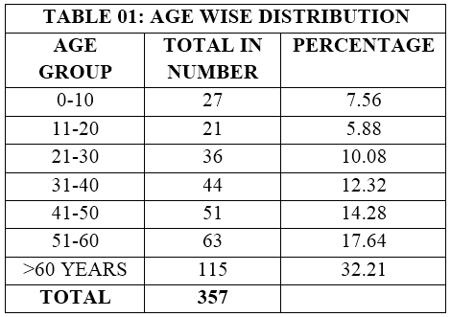

|  |  |  |
| --- | --- | --- |
| **TABLE 02: SAMPLE WISE DISTRIBUTION** | | |
| **SAMPLE** | **TOTAL IN NUMBER** | **PERCENTAGE** |
| ASCITIC FLUID | 2 | 0.56 |
| BAL | 18 | 5.04 |
| BLOOD | 49 | 13.73 |
| CSF | 1 | 0.28 |
| EAR SWAB | 1 | 0.28 |
| ET | 138 | 38.66 |
| PLUERAL FLUID | 3 | 0.84 |
| PUS | 64 | 17.93 |
| SPUTUM | 67 | 18.77 |
| URINE | 11 | 3.08 |
| CATHETER TIP | 1 | 0.28 |
| ORAL CAVITY | 1 | 0.28 |
| SKIN SCRAPPINGS | 1 | 0.28 |
| **TOTAL** | **357** |  |

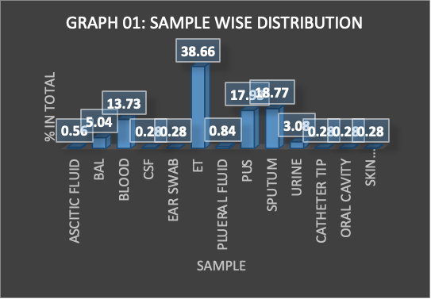

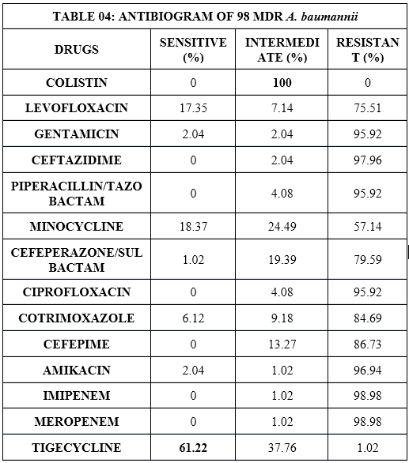

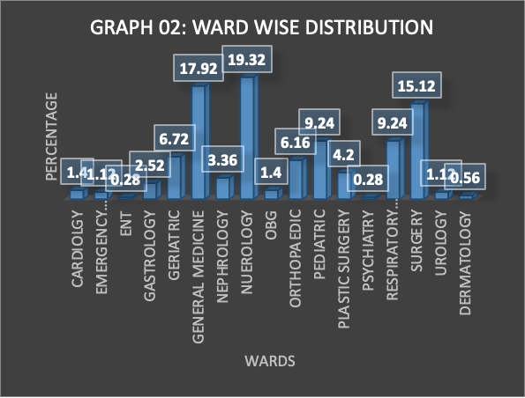

|  |  |  |
| --- | --- | --- |
| **TABLE 03:WARD WISE DISTRIBUTION** | | |
| **WARDS** | **TOTAL IN NO.** | **PERCENTAGE** |
| CARDIOLGY | 5 | 1.40 |
| EMERGENCY | 41 | 1.12 |
| ENT | 9 | 0.28 |
| GASTROLOGY | 24 | 2.52 |
| GERIATRIC | 64 | 6.72 |
| MEDICINE | 12 | 17.92 |
| NEPHROLOGY | 69 | 3.36 |
| NUEROLOGY | 5 | 19.32 |
| OBG | 22 | 1.40 |
| ORTHOPAEDIC | 33 | 6.16 |
| PEDIATRIC | 15 | 9.24 |
| PLASTIC SURGERY | 1 | 4.20 |
| PSYCHIATRY | 33 | 0.28 |
| RESPIRATORY MEDICINE | 54 | 9.24 |
| SURGERY | 4 | 15.12 |
| UROLOGY | 2 | 1.12 |
| DERMATOLOGY | 1 | 0.56 |
| **TOTAL** | **357** |  |